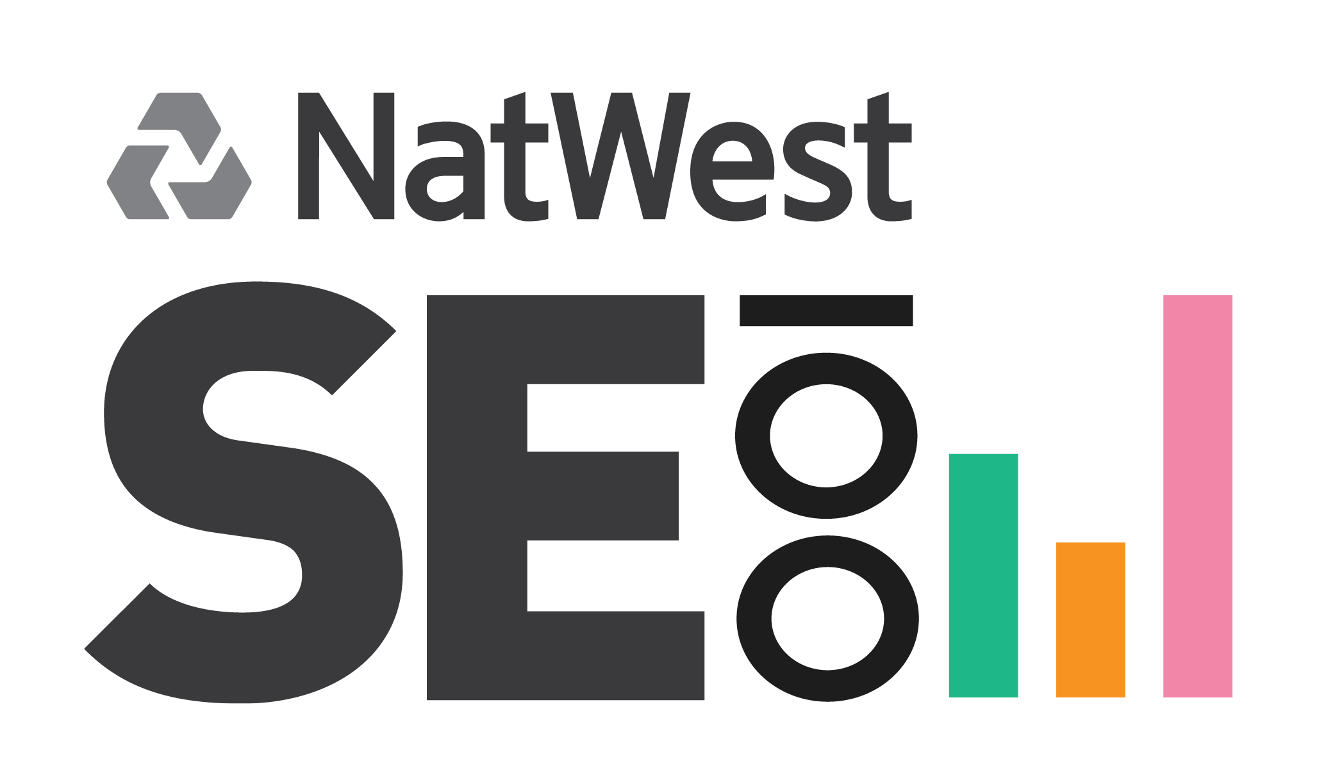

Press Release
Embargoed until 05 October 2015

NatWest SE100 announces shortlist for 2015 Awards
The UK’s top performing social enterprises in the running to win a share of over £32k prize fund

Now in its 6th year, the leading market intelligence tool for social ventures, the NatWest SE100 Index, is pleased to announce the shortlist for its 2015 awards.

The Index is an online listing of social ventures, ranked and scored according to their growth and social impact.

The 2015 winners will win a share of over £32, 000 in prize money that will be awarded at the NatWest SE100 Annual Awards on the 19th October 2015, at the Good Deals social investment conference in London. The shortlist is divided into five categories: Sustainable Growth, Social Impact, Trailblazing Newcomer and the Resilience and Storyteller award.

A total of 21 organisations have been shortlisted from all over the UK highlighting the strength of the social enterprise sector and its ability to create both social change and economic growth nationwide.

Regional represented:
- 2 from the North West
- 2 from the East Midlands
- 1 from the North East
- 8 from London
- 3 from the West Midlands
- 1 from Scotland
- 2 from East of England

Sectors represented:
- 5 from Education and Youth
- 4 from Health and Social Care
- 4 from Employment and Training
- As well as…. Regeneration and Community Development, Environment and Recycling, Housing, Retail, Finance, Marketing and Communications

Growth champion nominees:
Blue Ventures
Dementia Adventures
Teaching Leaders
The Education Business Partnership (EBP)

Impact champion nominees:
Ashley Community Housing
Community Together
FRC Group
Kelvin Valley Honey
MyBnk

Trailblazing newcomer nominees:
Andiamo
Developing Youth Practice
HumanCamera
Sweet Cavanagh

Storyteller award nominees:
Aduna
Blue Ventures
Echo Your Sport
Human Camera
John Taylor Hospice
Little Forest Folk

Resilience award nominees:
Bita Pathways
Five Lamps
Social Enterprise Kent
The Reader

Julie Baker, Head of Enterprise, NatWest, said: ““Social Enterprises make a massive difference to local economies and communities across the UK and beyond. They are run by inspirational people who want to make a difference. That is why at NatWest we want to support them to get access to the finance, support and networks they need to flourish. That way not only do they benefit, but the economy benefits and our society benefits. We congratulate all shortlisted enterprises and look forward to celebrating their success at the awards ceremony on 19th October.”

- ENDS -

Press Contacts
Sarah Gilbert: sarahgilbert@matterandco.com 07854 712318
Emily Benbow: emily@matterandco.com 07791364887
Rachel Pidgeon: Rachel@matterandco.com 07503 782489

T: +44 (0)208 8533 8893

Notes to editors

Suggested tweets:

- Congratulations to those shortlisted for the @NatWestbusiness @SE100 Awards 2015! #SocEnt

- 21 inspiring organisations have been shortlisted for the @NatWestbusiness @SE100 Awards [LINK] #SocEnt

- The @NatWestbusiness @SE100 awards shortlist is out! [LINK] Winners to be announced at #criticalmass15

Notes to editors

Photos are available on request

About the NatWest SE100 Index

The NatWest SE100 Index is open to any organisation delivering social, environmental or economic change. It is created by Matter&Co in partnership with the Royal Bank of Scotland and RBS Inspiring Enterprise with the support of Buzzacott and the Social Value UK. For more information visit se100.net.

The NatWest SE100 Index is an online listing of social ventures, ranked and scored according to their growth and social impact. The live market intelligence platform is designed to provide a substantial data resource for investors, commissioners and policymakers as they seek to understand the landscape of the social economy and identify top performers across the UK.

About NatWest Community Banking

NatWest was the first bank in the UK to establish a Community Banking Team. Since 1999, the Team has worked hard to break down the barriers to enterprise across Britain by creating opportunities for all sections of society. The bank has a team of locally based Specialist Mangers throughout Britain, committed to helping new start-up businesses and enabling deprived neighbourhoods to be more enterprising and build stronger communities. For more information contact the Community Banking team: communitybanking@rbs.co.uk

About RBS Inspiring Enterprise

NatWest is part of the Royal Bank of Scotland. From the classroom to the boardroom, RBS is inspiring enterprise at every stage of the journey. Starting and running a business can be both exciting and challenging. The Royal Bank of Scotland understands that people need the right combination of support, advice and funding to get started and achieve their ambitions. That’s why they provide a wide range of support for businesses of all shapes and sizes, in every sector of the economy. The Royal Bank of Scotland also knows that people need help to explore the idea of enterprise, unlock their potential, and gain the right skills, knowledge and networks before they can achieve their ambitions. Inspiring Enterprise draws together the work that they do, including work with partners and charities, to help people explore and develop their enterprise potential. The Royal Bank of Scotland is focusing additional efforts on three groups that they feel could play a stronger role in the entrepreneurial economy, if given more support; young people, women and social entrepreneurs.
www.rbs.com/inspiringenterprise

About Matter&Co
Matter&Co works with inspiring organisations across business and society to create positive social change through innovation and enterprise. We are a creative communications company with more than a decade in experience building success for ambitious, values-driven organisations – building marketing and PR campaigns, brands, events, print and digital media. Matter&Co is the company behind Good Deals the UK’s leading annual social investment event, and we are a strategic partner for the Deloitte Social Innovation Pioneers.
matterandco.com

